**Project Title**

**ONLINE MOVIE STORE SYSTEM**

**A PROJECT PLAN**

SUBMITTED BY:

DIVYA JAIN 12BCE0044

VANSH TULI 12BCE0196

SAURABH SINHA 12BCE0598

**Faculty:** Prof LYDIA JANE G

**Slot:**B2

**Software Engineering**

**CSE325**

** VIT**

U N I V E R S I T Y

(Estd. u/s 3 of UGC Act 1956)

Vellore - 632 014, Tamil Nadu, India

**School of Computing Science and Engineering**

1. PROBLEM STATEMENT

Online movie store system is a form of electronic commerce which allows consumers to directly buy CD’s from a seller over the Internet. Any new seller can join by signing up easily.

It is a unique thing because we don’t have sites that exclusively sell CD’s. So we will have a full collection of movies from all eras.

1. PROBLEM OBJECTIVE

Online movie Store System Software’s main purpose is to provide customers with the possibility to perform online purchases on products already on store. Customers are identified properly and are able to perform online transactions using two kinds of methods: either using credit card or banking documents. Online Customers are divided on two categories upon user account types: seller and buyer.

The customer is able to operate throughout the system after properly authenticated. He is able to create a cart and add products to it or delete them as well. Once the purchase is confirmed by the customer and admitted by shop commission, customer details come into use in order to define the shipping address and other supplementary information. Customer is given the possibility to view and print some information regarding his activity on the shop. For instance he can print the number of purchases completed by him from the beginning of the current year.

He can print the status of previously performed purchases and decide whether to cancel or not a specific purchase if it is still in “Not available” status. After the purchase he will get a confirmation mail.

During the process of product selection and addition to cart specifying correspond quantity the system automatically checks if the product is available within the quantity or not. In case of negative response the system generates a request to the product supplier. Stated in short terms this is the overall situation on hand.

1. FEASIBILITY STUDY

The scope of this project is to design and develop a system that is necessary to shops when they need to operate online, sell products online. The shop can keep an electronic history of all purchases and transactions. This gives more control over the operations that the company offers. The system can be adapted to a range of shops from simple small ones to big markets. A shop can outsource the function of shipping to another external company or can handle it itself. Project is feasible from customer perspective, limits the range of customers to only those who have internet connection on some form and have a bank account in hand.

The aim of this project is to promote an efficient, user-friendly, time-fashionable, safe way for customers to buy and receive products without being physically at a shop thus using virtual money.

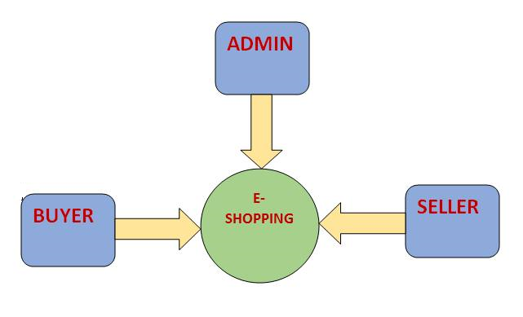

1. PROCESS MODEL

The process model chosen for the development of this software system is a **modification of the incremental process model.** The traditional incremental modelis a method of software development where the model is designed, implemented and tested incrementally (a little more is added each time) until the product is finished. It involves both development and maintenance. The product is defined as finished when it satisfies all of its requirements.

The modified model allows development as well as the initiation of the next increment cycle simultaneously. That is once the product is ready for construction; both, the construction of current cycle as well as the communication for the next increment can take place at the same time. However, construction of the next portion starts only after the deployment of the previous cycle. This is done in order to implement and act upon the customer feedback.

The basic idea behind this method is to develop a system through repeated cycles in smaller portions (incremental), and at the same time make judicious use of the human resources available for the development of this software system.

1. DELIVERABLES

ONLINE MOVIE STORE SYSTEM is aimed towards the sellers who want to reach out to the maximum cross-section of customer and common people who can be potential customer. This project envisages bridging the gap between the seller and the customer. It should be user-friendly, ‘quick to learn’ and reliable software for the above purpose. It is intended to be a stand-alone product and should not depend on the availability of other software. It should run on both UNIX and Windows based platform.

**SOFTWARE INTERFACE:**

**Client on Internet :** Web Browser, Operating System (any)

**Client on Intranet:** Web Browser, Operating System (any)

**Data Base Server:** MySQL, Operating System (any)

**Development End:** HTML, CSS, ASP.net, MySQL, OS (Windows 7/8)

**HARDWARE INTERFACE(minimum requirements):**

**Client side:** Internet Explorer-6 and processor Intel Pentium III or AMD-800 MHz with RAM 128MB and disk space 100MB.

**Server side:** MY SQL and processor Intel Pentium III or AMD-800 MHz with RAM 128MB and disk space 100MB

1. PROJECT SCHEDULING

# Gantt Chart



PERT CHART

